**Section 0**

$ git mkdir project_dir

$ cd project_dir

$ git init

$ touch index.html

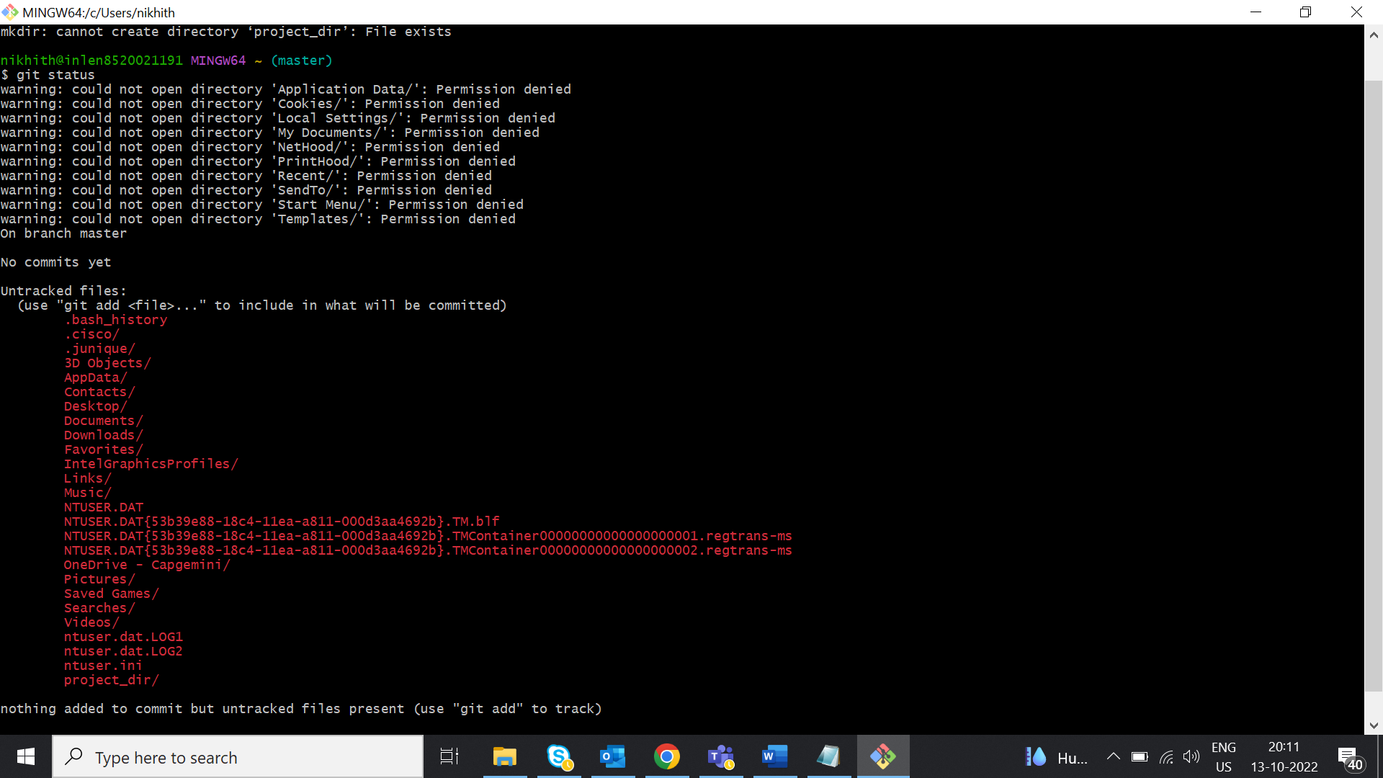

$ git add index.html

$ git commit -m "index file added"

[master c23b3ef] index file added

1 file changed, 0 insertions(+), 0 deletions(-)

create mode 100644 index.html

$ touch info.txt

$ git status

On branch master

Your branch is up to date with 'origin/master'.

Changes not staged for commit:

(use "git add <file>..." to update what will be committed)

(use "git restore <file>..." to discard changes in working directory)

modified: index.html

Untracked files:

(use "git add <file>..." to include in what will be committed)

info.txt

no changes added to commit (use "git add" and/or "git commit -a")

nikhith@inlen8520021191 MINGW64 ~/project_dir (master)

$ git add index.html

nikhith@inlen8520021191 MINGW64 ~/project_dir (master)

$ git status

On branch master

Your branch is up to date with 'origin/master'.

Changes to be committed:

(use "git restore --staged <file>..." to unstage)

modified: index.html

Untracked files:

(use "git add <file>..." to include in what will be committed)

info.txt

$ touch .gitignore

info.txt

hello.txt

nikhith@inlen8520021191 MINGW64 ~/project_dir (master)

$ git add .

nikhith@inlen8520021191 MINGW64 ~/project_dir (master)

$ git status

On branch master

Your branch is up to date with 'origin/master'.

Changes to be committed:

(use "git restore --staged <file>..." to unstage)

new file: .gitignore

modified: index.html

nikhith@inlen8520021191 MINGW64 ~/project_dir (master)

$ git add index.html

nikhith@inlen8520021191 MINGW64 ~/project_dir (master)

$ git commit -m "commit index file"

[master 5b2045b] commit index file

2 files changed, 7 insertions(+)

create mode 100644 .gitignore

nikhith@inlen8520021191 MINGW64 ~/project_dir (master)

$ git log

commit 5b2045b5eb12493408fcac02bafb1e7882646f04 (HEAD -> master)

Author: nikhithakundar <nikhithamogaveera2002@gamil.com>

Date: Thu Oct 13 22:22:10 2022 +0530

commit index file

commit c23b3efb6a4bf99e93c6da418b3d6defe80a960e (origin/master)

Author: nikhithakundar <nikhithamogaveera2002@gamil.com>

Date: Thu Oct 13 21:10:22 2022 +0530

index file added

commit 4f852eb696d9b75901868c00259905cdb97801ab

Author: nikhithakundar <nikhithamogaveera2002@gamil.com>

Date: Thu Oct 13 21:09:45 2022 +0530

first commit

$ git restore index.html

nikhith@inlen8520021191 MINGW64 ~/project_dir (master)

$ git add index.html

nikhith@inlen8520021191 MINGW64 ~/project_dir (master)

$ git status

On branch master

Your branch is ahead of 'origin/master' by 1 commit.

(use "git push" to publish your local commits)

Changes to be committed:

(use "git restore --staged <file>..." to unstage)

modified: index.html

$ git restore --staged index.html

$ git status

On branch master

Your branch is ahead of 'origin/master' by 1 commit.

(use "git push" to publish your local commits)

Changes not staged for commit:

(use "git add <file>..." to update what will be committed)

(use "git restore <file>..." to discard changes in working directory)

modified: index.html

no changes added to commit (use "git add" and/or "git commit -a")

$ git config --global alias.my-add add

$ git add .

$ git status

On branch master

Your branch is up to date with 'origin/master'.

Changes to be committed:

(use "git restore --staged <file>..." to unstage)

modified: index.html

$ git commit -m "staged index"

\[master 8da9395] staged index

1 file changed, 2 insertions(+)

$ git log

commit 8da93955a1662276abb4596d50ca4c5003e67602 (HEAD -> master)

Author: nikhithakundar <nikhithamogaveera2002@gmail.com>

Date: Fri Oct 14 09:28:59 2022 +0530

staged index

commit 5b2045b5eb12493408fcac02bafb1e7882646f04 (origin/master)

Author: nikhithakundar <nikhithamogaveera2002@gamil.com>

Date: Thu Oct 13 22:22:10 2022 +0530

commit index file

commit c23b3efb6a4bf99e93c6da418b3d6defe80a960e

Author: nikhithakundar <nikhithamogaveera2002@gamil.com>

Date: Thu Oct 13 21:10:22 2022 +0530

index file added

commit 4f852eb696d9b75901868c00259905cdb97801ab

Author: nikhithakundar <nikhithamogaveera2002@gamil.com>

Date: Thu Oct 13 21:09:45 2022 +0530

first commit

$ git revert 8da93955a1662276abb4596d50ca4c5003e67602

[master 9b9ffc5] Revert "staged index"

1 file changed, 2 deletions(-)

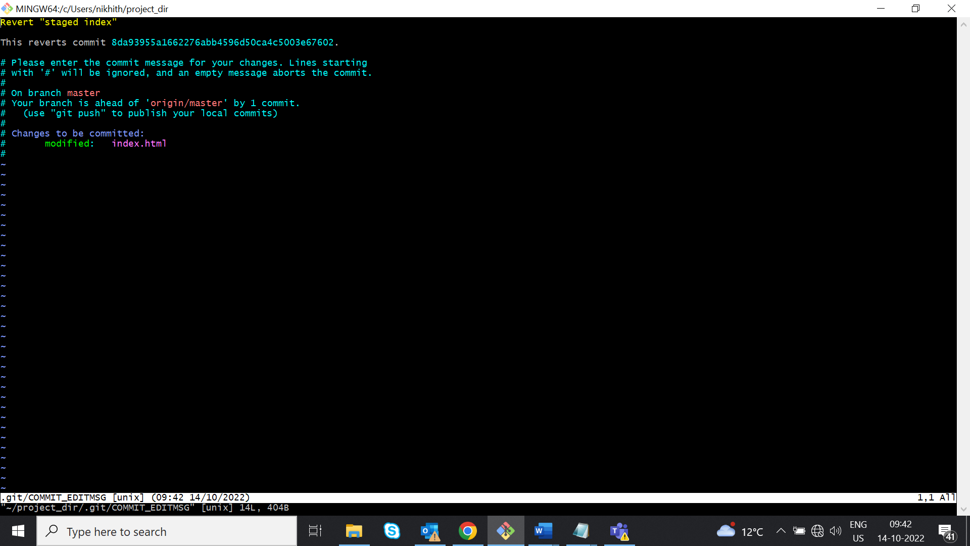

**Section 1**

$ mkdir assignment

$ cd assignment

$ git init

$ touch README.txt

nikhith@inlen8520021191 MINGW64 ~/assignment (master)

$ git add .

nikhith@inlen8520021191 MINGW64 ~/assignment (master)

$ git status

On branch master

No commits yet

Changes to be committed:

(use "git rm --cached <file>..." to unstage)

new file: README.txt

nikhith@inlen8520021191 MINGW64 ~/assignment (master)

$ git commit -m "commiting README.txt"

[master (root-commit) 3d8518c] commiting README.txt

1 file changed, 1 insertion(+)

create mode 100644 README.txt

$ git branch html-assignments

nikhith@inlen8520021191 MINGW64 ~/assignment (master)

$ git checkout html-assignments

Switched to branch 'html-assignments'

nikhith@inlen8520021191 MINGW64 ~/assignment (html-assignments)

$ git checkout assignment --index.html

error: unknown option `index.html'

usage: git checkout [<options>] <branch>

or: git checkout [<options>] [<branch>] -- <file>...

-b <branch> create and checkout a new branch

-B <branch> create/reset and checkout a branch

-l create reflog for new branch

--guess second guess 'git checkout <no-such-branch>' (default)

--overlay use overlay mode (default)

-q, --quiet suppress progress reporting

--recurse-submodules[=<checkout>]

control recursive updating of submodules

--progress force progress reporting

-m, --merge perform a 3-way merge with the new branch

--conflict <style> conflict style (merge, diff3, or zdiff3)

-d, --detach detach HEAD at named commit

-t, --track[=(direct|inherit)]

-t, --track[=(direct|inherit)]

set branch tracking configuration

-f, --force force checkout (throw away local modifications)

--orphan <new-branch>

new unparented branch

--overwrite-ignore update ignored files (default)

--ignore-other-worktrees

do not check if another worktree is holding the given ref

-2, --ours checkout our version for unmerged files

-3, --theirs checkout their version for unmerged files

-p, --patch select hunks interactively

--ignore-skip-worktree-bits

do not limit pathspecs to sparse entries only

--pathspec-from-file <file>

read pathspec from file

--pathspec-file-nul with --pathspec-from-file, pathspec elements are separated with NUL character

nikhith@inlen8520021191 MINGW64 ~/assignment (html-assignments)

$ git status

On branch html-assignments

Untracked files:

(use "git add <file>..." to include in what will be committed)

index.html

nothing added to commit but untracked files present (use "git add" to track)

nikhith@inlen8520021191 MINGW64 ~/assignment (html-assignments)

$ git add .

nikhith@inlen8520021191 MINGW64 ~/assignment (html-assignments)

$ git status

On branch html-assignments

Changes to be committed:

(use "git restore --staged <file>..." to unstage)

new file: index.html

nikhith@inlen8520021191 MINGW64 ~/assignment (html-assignments)

$ git commit -m "copying html index"

[html-assignments 29e7158] copying html index

1 file changed, 10 insertions(+)

create mode 100644 index.html

nikhith@inlen8520021191 MINGW64 ~/assignment (html-assignments)

$ git branch

* html-assignments

master

nikhith@inlen8520021191 MINGW64 ~/assignment (html-assignments)

$ git checkout master

Switched to branch 'master'

nikhith@inlen8520021191 MINGW64 ~/assignment (master)

$ git remote add origin https://github.com/nikhithakundar/demo.git

error: remote origin already exists.

nikhith@inlen8520021191 MINGW64 ~/assignment (master)

$ git push -u origin master

Enumerating objects: 3, done.

Counting objects: 100% (3/3), done.

Writing objects: 100% (3/3), 279 bytes | 279.00 KiB/s, done.

Total 3 (delta 0), reused 0 (delta 0), pack-reused 0

To https://github.com/nikhithakundar/demo.git

* [new branch] master -> master

branch 'master' set up to track 'origin/master'.

nikhith@inlen8520021191 MINGW64 ~/assignment (master)

$ git checkout html-assignments

Switched to branch 'html-assignments'

nikhith@inlen8520021191 MINGW64 ~/assignment (html-assignments)

$ git push -u origin html-assignments

Enumerating objects: 4, done.

Counting objects: 100% (4/4), done.

Delta compression using up to 8 threads

Compressing objects: 100% (3/3), done.

Writing objects: 100% (3/3), 399 bytes | 399.00 KiB/s, done.

Total 3 (delta 0), reused 0 (delta 0), pack-reused 0

remote:

remote: Create a pull request for 'html-assignments' on GitHub by visiting:

remote: https://github.com/nikhithakundar/demo/pull/new/html-assignments

remote:

To https://github.com/nikhithakundar/demo.git

* [new branch] html-assignments -> html-assignments

branch 'html-assignments' set up to track 'origin/html-assignments'.

nikhith@inlen8520021191 MINGW64 ~/assignment (html-assignments)

$ git status

On branch html-assignments

Your branch is up to date with 'origin/html-assignments'.

nothing to commit, working tree clean

nikhith@inlen8520021191 MINGW64 ~/assignment (html-assignments)

$ git pull

remote: Enumerating objects: 5, done.

remote: Counting objects: 100% (5/5), done.

remote: Compressing objects: 100% (3/3), done.

remote: Total 3 (delta 1), reused 0 (delta 0), pack-reused 0

Unpacking objects: 100% (3/3), 720 bytes | 90.00 KiB/s, done.

From https://github.com/nikhithakundar/demo

29e7158..0cf5f92 html-assignments -> origin/html-assignments

$ git checkout master

Switched to branch 'master'

Your branch is up to date with 'origin/master'.

nikhith@inlen8520021191 MINGW64 ~/assignment (master)

$ git status

On branch master

Your branch is up to date with 'origin/master'.

nothing to commit, working tree clean

nikhith@inlen8520021191 MINGW64 ~/assignment (master)

$ git status

On branch master

Your branch is up to date with 'origin/master'.

Changes not staged for commit:

(use "git add <file>..." to update what will be committed)

(use "git restore <file>..." to discard changes in working directory)

modified: README.txt

no changes added to commit (use "git add" and/or "git commit -a")

nikhith@inlen8520021191 MINGW64 ~/assignment (master)

$ git add README.txt

nikhith@inlen8520021191 MINGW64 ~/assignment (master)

$ git status

On branch master

Your branch is up to date with 'origin/master'.

Changes to be committed:

(use "git restore --staged <file>..." to unstage)

modified: README.txt

nikhith@inlen8520021191 MINGW64 ~/assignment (master)

$ git commit -m "changing README.txt to master"

[master 0d0fa7c] changing README.txt to master

1 file changed, 2 insertions(+), 1 deletion(-)

nikhith@inlen8520021191 MINGW64 ~/assignment (master)

$ git push

Enumerating objects: 5, done.

Counting objects: 100% (5/5), done.

Delta compression using up to 8 threads

Compressing objects: 100% (2/2), done.

Writing objects: 100% (3/3), 359 bytes | 359.00 KiB/s, done.

Total 3 (delta 0), reused 0 (delta 0), pack-reused 0

To https://github.com/nikhithakundar/demo.git

3d8518c..0d0fa7c master -> master

nikhith@inlen8520021191 MINGW64 ~/assignment (master)

$ git checkout html-assignments

Switched to branch 'html-assignments'

Your branch is up to date with 'origin/html-assignments'.

nikhith@inlen8520021191 MINGW64 ~/assignment (html-assignments)

$ git pull

remote: Enumerating objects: 5, done.

remote: Counting objects: 100% (5/5), done.

remote: Compressing objects: 100% (3/3), done.

remote: Total 3 (delta 1), reused 0 (delta 0), pack-reused 0

Unpacking objects: 100% (3/3), 754 bytes | 50.00 KiB/s, done.

From https://github.com/nikhithakundar/demo

0cf5f92..305bc7a html-assignments -> origin/html-assignments

Updating 0cf5f92..305bc7a

Fast-forward

index.html | 1 +

1 file changed, 1 insertion(+)

nikhith@inlen8520021191 MINGW64 ~/assignment (html-assignments)

$ git checkout master

Switched to branch 'master'

Your branch is up to date with 'origin/master'.

nikhith@inlen8520021191 MINGW64 ~/assignment (master)

$ git checkout html-assignments

Switched to branch 'html-assignments'

Your branch is up to date with 'origin/html-assignments'.

nikhith@inlen8520021191 MINGW64 ~/assignment (html-assignments)

$ git merge master

Merge made by the 'ort' strategy.

README.txt | 3 ++-

1 file changed, 2 insertions(+), 1 deletion(-)

**Section 2**

nikhith@inlen8520021191 MINGW64 ~ (master)

$ cd assignment

nikhith@inlen8520021191 MINGW64 ~/assignment (html-assignments)

$ git branch css-assignments

nikhith@inlen8520021191 MINGW64 ~/assignment (html-assignments)

$ git checkout css-assignments

Switched to branch 'css-assignments'

nikhith@inlen8520021191 MINGW64 ~/assignment (css-assignments)

$ touch test.css

nikhith@inlen8520021191 MINGW64 ~/assignment (css-assignments)

$ git status

On branch css-assignments

Untracked files:

(use "git add <file>..." to include in what will be committed)

test.css

nothing added to commit but untracked files present (use "git add" to track)

nikhith@inlen8520021191 MINGW64 ~/assignment (css-assignments)

$ git add test.css

nikhith@inlen8520021191 MINGW64 ~/assignment (css-assignments)

$ git status

On branch css-assignments

Changes to be committed:

(use "git restore --staged <file>..." to unstage)

new file: test.css

nikhith@inlen8520021191 MINGW64 ~/assignment (css-assignments)

$ git commit -m "commiting test.css"

[css-assignments 08b0b5b] commiting test.css

1 file changed, 13 insertions(+)

create mode 100644 test.css

nikhith@inlen8520021191 MINGW64 ~/assignment (css-assignments)

$ git status

On branch css-assignments

Changes not staged for commit:

(use "git add <file>..." to update what will be committed)

(use "git restore <file>..." to discard changes in working directory)

modified: README.txt

nikhith@inlen8520021191 MINGW64 ~/assignment (css-assignments)

$ git add README.txt

nikhith@inlen8520021191 MINGW64 ~/assignment (css-assignments)

$ git status

On branch css-assignments

Changes to be committed:

(use "git restore --staged <file>..." to unstage)

modified: README.txt

nikhith@inlen8520021191 MINGW64 ~/assignment (css-assignments)

$ git commit -m "commiting README.txt file"

[css-assignments 3799f86] commiting README.txt file

1 file changed, 2 insertions(+)

nikhith@inlen8520021191 MINGW64 ~/assignment (css-assignments)

$ git checkout master

Switched to branch 'master'

Your branch is up to date with 'origin/master'.

nikhith@inlen8520021191 MINGW64 ~/assignment (master)

$ git status

On branch master

Your branch is up to date with 'origin/master'.

Changes not staged for commit:

(use "git add <file>..." to update what will be committed)

(use "git restore <file>..." to discard changes in working directory)

modified: README.txt

no changes added to commit (use "git add" and/or "git commit -a")

nikhith@inlen8520021191 MINGW64 ~/assignment (master)

$ git add README.txt

nikhith@inlen8520021191 MINGW64 ~/assignment (master)

$ git status

On branch master

Your branch is up to date with 'origin/master'.

Changes to be committed:

(use "git restore --staged <file>..." to unstage)

modified: README.txt

nikhith@inlen8520021191 MINGW64 ~/assignment (master)

$ git commit -m "changing the third line for master in README.txt"

[master dc0f1be] changing the third line for master in README.txt

1 file changed, 2 insertions(+), 1 deletion(-)

nikhith@inlen8520021191 MINGW64 ~/assignment (master)

$ git checkout css-assignments

Switched to branch 'css-assignments'

nikhith@inlen8520021191 MINGW64 ~/assignment (css-assignments)

$ git status

On branch css-assignments

Changes not staged for commit:

(use "git add <file>..." to update what will be committed)

(use "git restore <file>..." to discard changes in working directory)

modified: test.css

no changes added to commit (use "git add" and/or "git commit -a")

nikhith@inlen8520021191 MINGW64 ~/assignment (css-assignments)

$ git add test.css

nikhith@inlen8520021191 MINGW64 ~/assignment (css-assignments)

$ git status

On branch css-assignments

Changes to be committed:

(use "git restore --staged <file>..." to unstage)

modified: test.css

nikhith@inlen8520021191 MINGW64 ~/assignment (css-assignments)

$ git commit -m "committing test.css after mofifying"

[css-assignments b6bccea] committing test.css after mofifying

1 file changed, 4 insertions(+)

nikhith@inlen8520021191 MINGW64 ~/assignment (css-assignments)

$ git status

On branch css-assignments

nothing to commit, working tree clean

nikhith@inlen8520021191 MINGW64 ~/assignment (master|MERGING)

$ git checkout master

Already on 'master'

M README.txt

A index.html

A test.css

Your branch is ahead of 'origin/master' by 1 commit.

(use "git push" to publish your local commits)

**Section 3**

nikhith@inlen8520021191 MINGW64 ~/assignment (css-assignments)

$ git status

On branch css-assignments

nothing to commit, working tree clean

nikhith@inlen8520021191 MINGW64 ~/assignment (css-assignments)

$ git branch js-assignments

nikhith@inlen8520021191 MINGW64 ~/assignment (css-assignments)

$ git checkout js-assignments

Switched to branch 'js-assignments'

nikhith@inlen8520021191 MINGW64 ~/assignment (js-assignments)

$ touch sample.js

nikhith@inlen8520021191 MINGW64 ~/assignment (js-assignments)

$ git add sample.js

nikhith@inlen8520021191 MINGW64 ~/assignment (js-assignments)

$ git status

On branch js-assignments

Changes to be committed:

(use "git restore --staged <file>..." to unstage)

new file: sample.js

nikhith@inlen8520021191 MINGW64 ~/assignment (js-assignments)

$ git commit -m "commiting sample.js"

[js-assignments 44b6982] commiting sample.js

1 file changed, 4 insertions(+)

create mode 100644 sample.js

nikhith@inlen8520021191 MINGW64 ~/assignment (js-assignments)

$ git status

On branch js-assignments

Changes not staged for commit:

(use "git add <file>..." to update what will be committed)

(use "git restore <file>..." to discard changes in working directory)

modified: README.txt

no changes added to commit (use "git add" and/or "git commit -a")

nikhith@inlen8520021191 MINGW64 ~/assignment (js-assignments)

$ git add README.txt

nikhith@inlen8520021191 MINGW64 ~/assignment (js-assignments)

$ git status

On branch js-assignments

Changes to be committed:

(use "git restore --staged <file>..." to unstage)

modified: README.txt

nikhith@inlen8520021191 MINGW64 ~/assignment (js-assignments)

$ git commit -m "commiting README.txt in js-assignment"

[js-assignments 655cec4] commiting README.txt in js-assignment

1 file changed, 1 insertion(+)

nikhith@inlen8520021191 MINGW64 ~/assignment (js-assignments)

$ git checkout master

Switched to branch 'master'

Your branch is ahead of 'origin/master' by 1 commit.

(use "git push" to publish your local commits)

nikhith@inlen8520021191 MINGW64 ~/assignment (master)

$ git status

On branch master

Your branch is ahead of 'origin/master' by 1 commit.

(use "git push" to publish your local commits)

Changes not staged for commit:

(use "git add <file>..." to update what will be committed)

(use "git restore <file>..." to discard changes in working directory)

modified: README.txt

no changes added to commit (use "git add" and/or "git commit -a")

nikhith@inlen8520021191 MINGW64 ~/assignment (master)

$ git add README.txt

nikhith@inlen8520021191 MINGW64 ~/assignment (master)

$ git status

On branch master

Your branch is ahead of 'origin/master' by 1 commit.

(use "git push" to publish your local commits)

Changes to be committed:

(use "git restore --staged <file>..." to unstage)

modified: README.txt

nikhith@inlen8520021191 MINGW64 ~/assignment (master)

$ git commit -m "commiting changes in readme.txt in master branch"

[master 8ae118b] commiting changes in readme.txt in master branch

1 file changed, 1 insertion(+)

nikhith@inlen8520021191 MINGW64 ~/assignment (master)

$ git checkout js-assignments

Switched to branch 'js-assignments'

nikhith@inlen8520021191 MINGW64 ~/assignment (js-assignments)

$ git status

On branch js-assignments

Changes not staged for commit:

(use "git add <file>..." to update what will be committed)

(use "git restore <file>..." to discard changes in working directory)

modified: sample.js

no changes added to commit (use "git add" and/or "git commit -a")

nikhith@inlen8520021191 MINGW64 ~/assignment (js-assignments)

$ git add sample.js

nikhith@inlen8520021191 MINGW64 ~/assignment (js-assignments)

$ git status

On branch js-assignments

Changes to be committed:

(use "git restore --staged <file>..." to unstage)

modified: sample.js

nikhith@inlen8520021191 MINGW64 ~/assignment (js-assignments)

$ git commit -m "commiting sample.js js-assignment"

[js-assignments bbe221a] commiting sample.js js-assignment

1 file changed, 13 insertions(+), 1 deletion(-)

nikhith@inlen8520021191 MINGW64 ~/assignment (js-assignments)

$ git checkout master

Switched to branch 'master'

Your branch is ahead of 'origin/master' by 2 commits.

(use "git push" to publish your local commits)

Created testfolder and cpy the index,sample,test

nikhith@inlen8520021191 MINGW64 ~/testfolder (master)

$ git init

Initialized empty Git repository in C:/Users/nikhith/testfolder/.git/

nikhith@inlen8520021191 MINGW64 ~/testfolder (master)

$ git add .

nikhith@inlen8520021191 MINGW64 ~/testfolder (master)

$ git commit -m "add all files into remote"

[master (root-commit) 0d4aad5] add all files into remote

3 files changed, 45 insertions(+)

create mode 100644 index.html

create mode 100644 sample.js

create mode 100644 test.css

nikhith@inlen8520021191 MINGW64 ~/testfolder (master)

$ git remote add origin https://github.com/nikhithakundar/freshersbatch-oct16.git

nikhith@inlen8520021191 MINGW64 ~/testfolder (master)

$ git push origin master

Enumerating objects: 5, done.

Counting objects: 100% (5/5), done.

Delta compression using up to 8 threads

Compressing objects: 100% (5/5), done.

Writing objects: 100% (5/5), 853 bytes | 426.00 KiB/s, done.

Total 5 (delta 0), reused 0 (delta 0), pack-reused 0

remote:

remote: Create a pull request for 'master' on GitHub by visiting:

remote: https://github.com/nikhithakundar/freshersbatch-oct16/pull/new/master

remote:

To https://github.com/nikhithakundar/freshersbatch-oct16.git

* [new branch] master -> master

**Section 4:**

